Stockholm School of Economics in Russia postpones the EMBA program 2020 and keeps the Scholarship for Swedish Chamber of Commerce members
The information about COVID-19 (Coronavirus) is changing rapidly. The restrictions announced due to the spread of coronavirus have also affected Stockholm School of Economics in Russia. Our priority now more than ever is the safety and well-being of our program participants and staff, as well as our social responsibility in front of the society overall. We have changed the schedule of all upcoming activities including educational modules.
The launch of the new Executive MBA GM21 group is postponed from March 25, 2020, to Autumn 2020. The exact date of the module will be announced as soon as the situation improves. At the moment, we expect to resume all our activities in full by the end of summer 2020 at the latest.
We're optimistic about the future, and the admission process goes on. You are hereby cordially invited to nominate an applicant within your organization to apply for the scholarship for the Executive MBA (EMBA) program in Russia.
Stockholm School of Economics in Russia in cooperation with Swedish Chamber of Commerce for Russia & CIS offers its members a scholarship, which implies a grant covering 30 % of the tuition fee for the EMBA program organized by SSE in Russia.
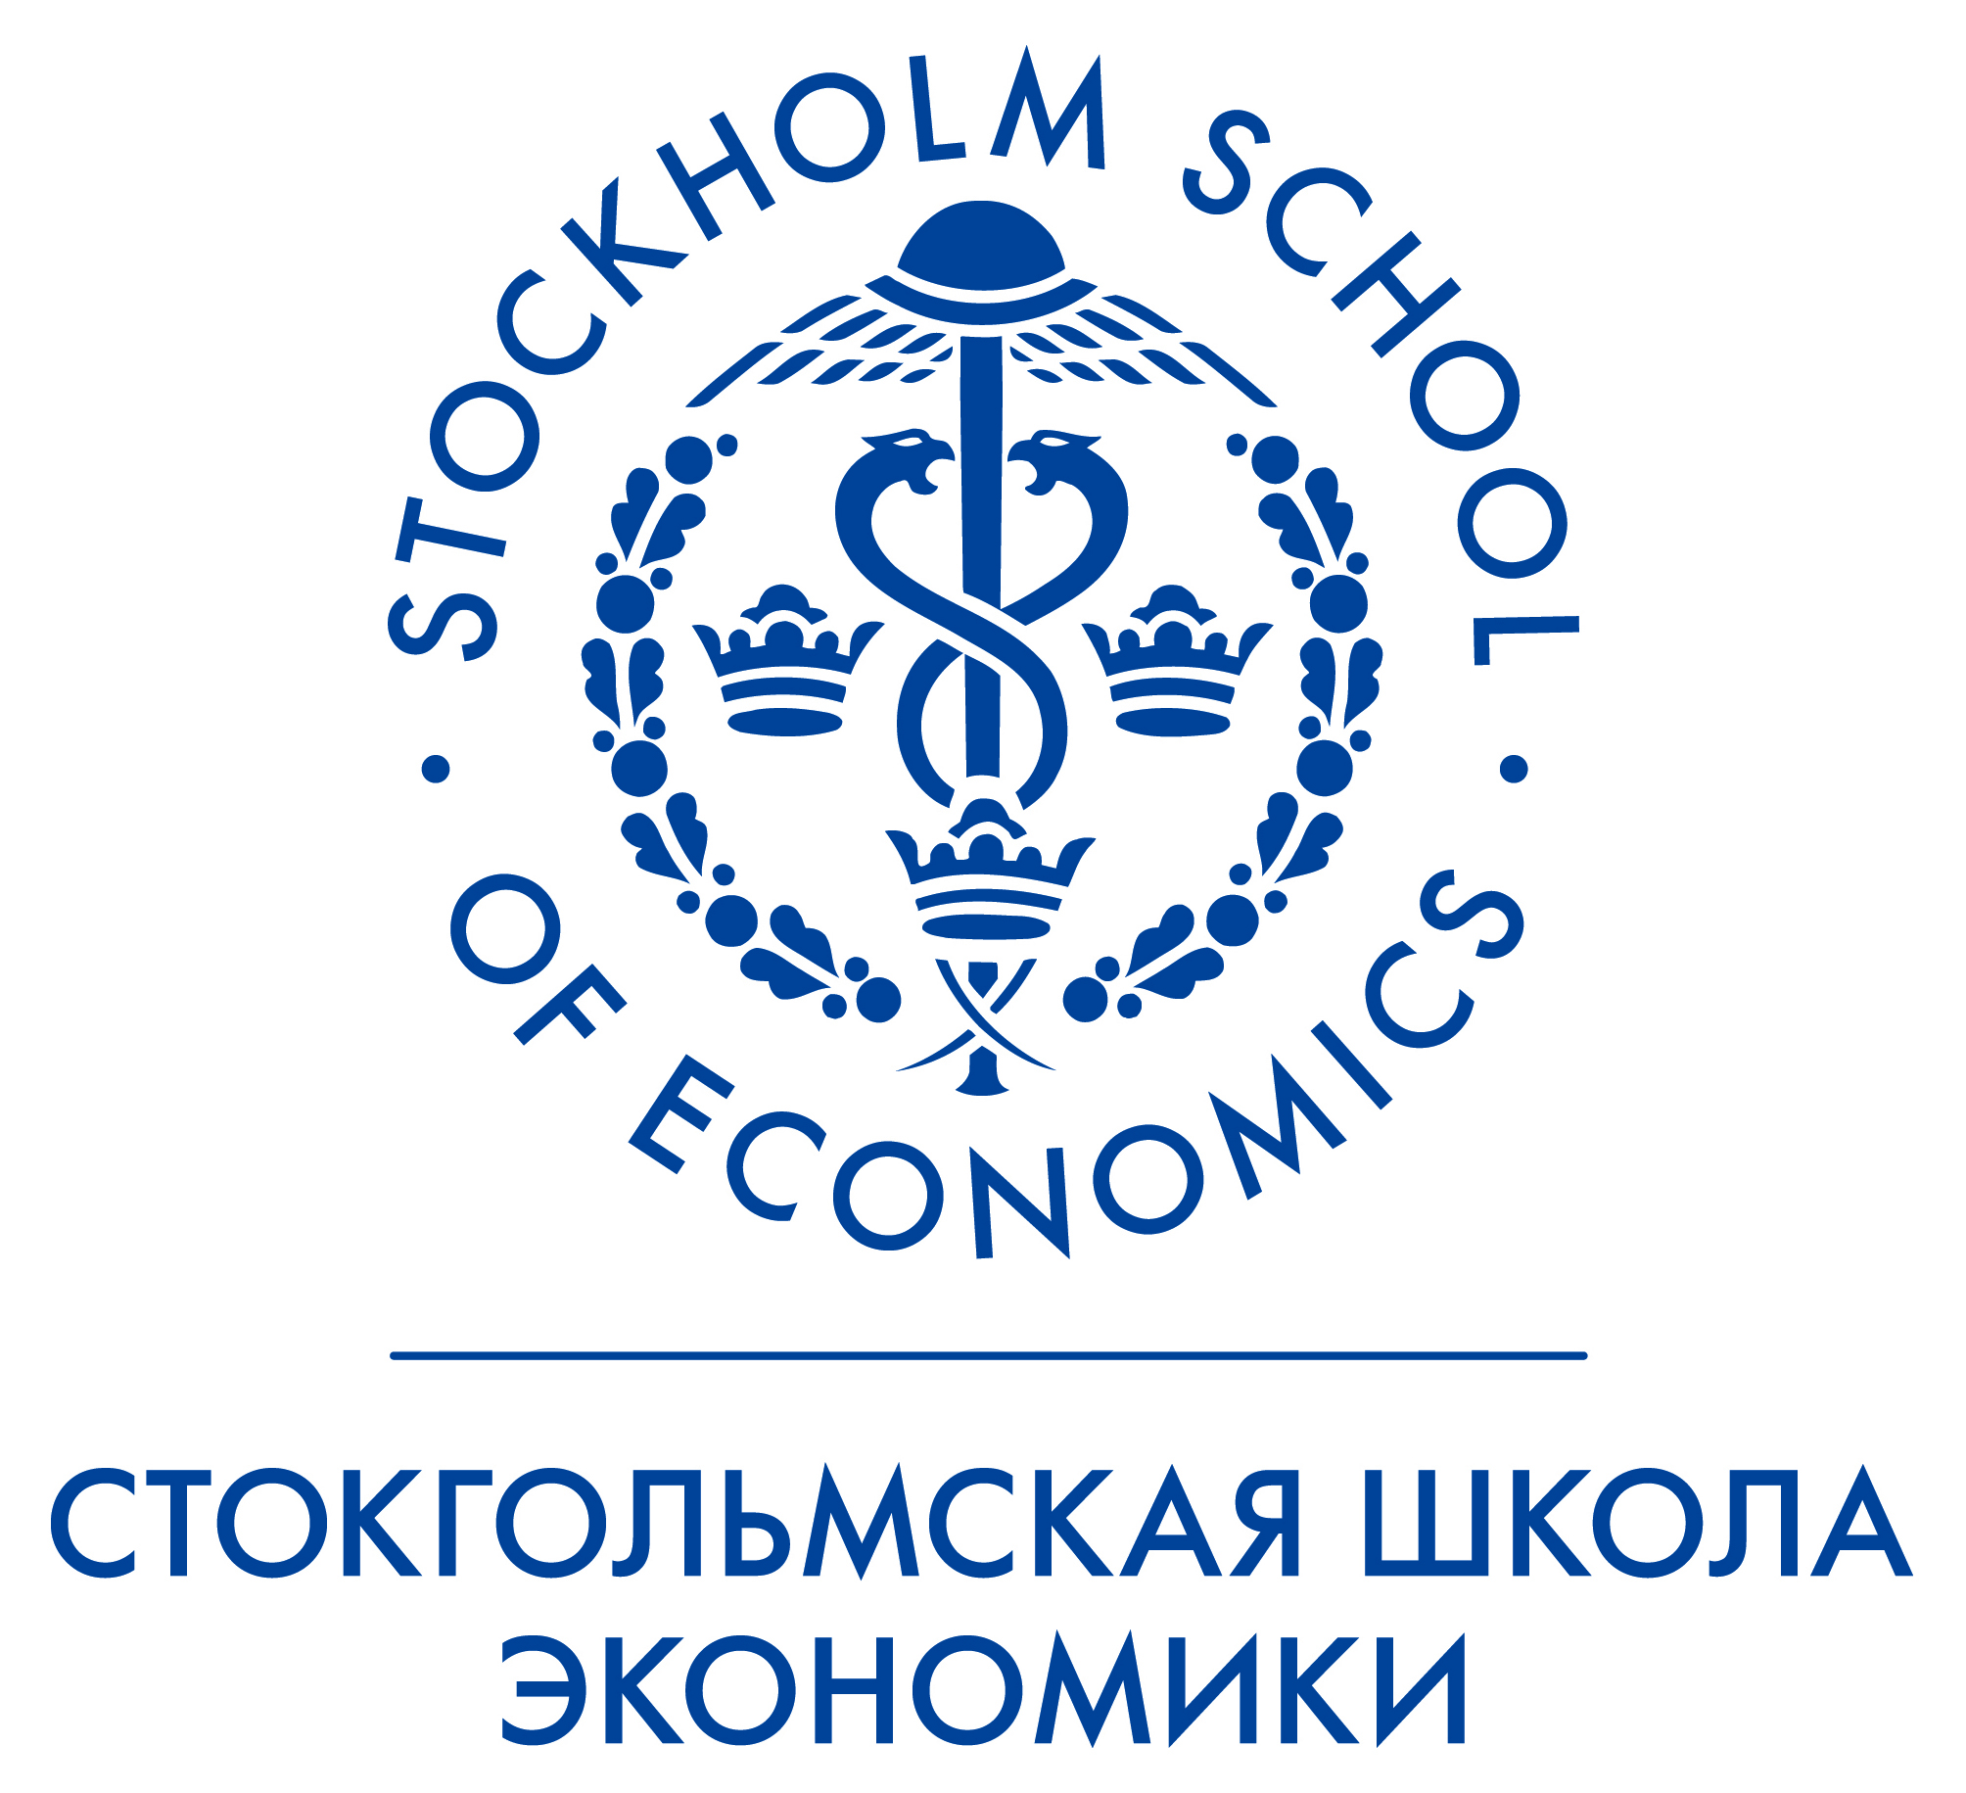
The Executive MBA Program is designed for English speaking managers, as well as ex-pats, who are interested in international course adapted to the specifics of Russian business environment.
Quick Facts:
Format: 13 modules with breaks of 3-5 weeks. Duration: 20 months
The teaching language: English.
Locations of modules: Moscow, St. Petersburg, Stockholm, Luleå, Tel Aviv.
Faculty: More than 90% of faculty come from Europe and other countries
Diploma of Executive Master of Business Administration issued by The Stockholm School of Economics (Sweden).
In addition to providing a first-class, competitive education in areas such as accounting and finance, economics, leadership and human resources, marketing, international business, operations management and strategy, the two-year journey includes personal development, consulting experience and an Executive Master Thesis. Your applicant will extend his or her professional network, get acquainted with top-managers of Russian enterprises, enter the alumni club and thus increases his or her efficiency.
You are welcome to visit the SSE Russia website to receive more detailed information about the new features of EMBA program.
The application deadline is August 1, 2020.
For further information regarding the program and its admissions, please, refer to the SSE Russia Sales Manager Victoria Kostikova via
email: victoria.kostikova@sserussia.org
or by phone (WhatsApp) on: +7 921 791 21 11

Stay well,
The Stockholm School of Economics in Russia

